Unit Creation and Introduction to Templates
and
Post-Implementation Templates

Speaker: Ms. Debbie Liberi, RET Program Coordinator and Resource Person, College of Engineering and Applied Science, University of Cincinnati
Date: Tuesday, June 19, 2018 & Tuesday, July 24, 2018
Time: 1-2:30 PM (June 19) & 10:45-11:30 am (July 24)
Venue: University of Cincinnati, Swift Hall, Room 608

Prepared by:
Dr. Dean Stocker, University of Cincinnati Blue Ash College, Blue Ash, Ohio
RET Participant for Project #4: “Air Quality Monitoring Near a Major Roadway”

These sessions were given by Debbie Liberi on Tuesday, June 19, 2018 from 1-2:30 PM and Thursday, July 24, 2018 from 10:45-11:30 am at the University of Cincinnati in Swift Hall, Room 608.

Debbie Liberi currently serves as the District Coordinator for the CEEMS grant at UC and as the Coordinator and Resource Person for the RET Program. She earned a BA in Biology from Wittenberg University and a Masters in Secondary Education from UC, as well as, a Masters in Library and Information Science from Kent State University. She was a middle school science teacher and high school librarian for 35 years with CPS. From 2000-2010, Debbie was a National Board Certified Teacher in Early Adolescence Science. She also served as a lead teacher in various mentoring roles for CPS. In addition, Debbie has served as an adjunct faculty in the Teachers College at UC and at Xavier University.

Ms. Liberi opened the first session by having participant’s text with their phones to connect to http://polleverywhere.com . She gave background information about herself and how she came to be a part of this program and then had participants take a pre-assessment quiz. She instructed participants to find the items related to templates in their binders and she covered the basic outline of Challenge-Based Learning (CBL).

The objectives of the first session were to locate the different sections of the template and identify their purposes; identify the sequential order of the development of a unit; and ask questions about the development of a Unit and Activity using the templates as a guide. Ms. Liberi then guided participants through the process with instructions for using the templates effectively (see Figure 1 below).

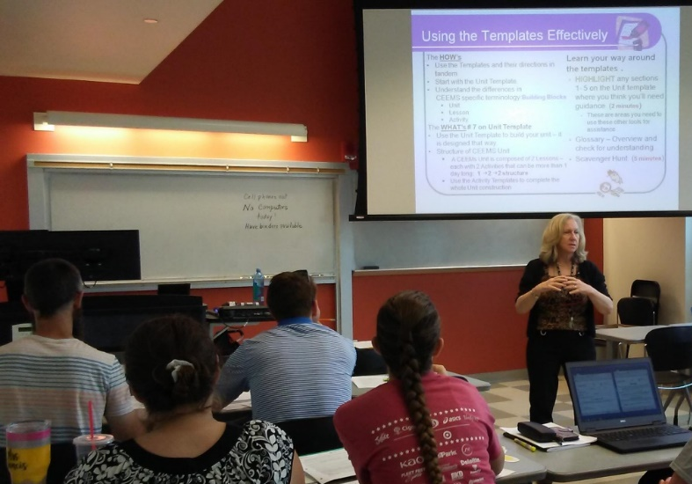
Figure 1: Ms. Liberi Describing How to Use the Provided Templates Effectively

There are four activities associated with each Unit, organized as follows: one unit, two lessons, with two activities each. Activities should be stand-alone and could be one or more days long, and often include more than one of the following:
- Big Idea: the broad concept under which the Unit falls.
- Essential question: drives the challenge, and is answered by the challenge.
- Hook is an inspirational way to compel the students to learn about the content.
- Challenge is the student-designed solution to the essential question.
- Guiding questions are the questions that need to be answered to answer the essential question.

Participants completed a scavenger hunt related to the templates (see Figure 2 below) to fully understand each element of the Unit and Activity Templates.

Figure 2: Participants Working on the Scavenger Hunt

Ms. Liberi stressed on the importance of developing assessments to be used throughout the process. The assessments should be measurable. Not “the student will explore…,” but “the student will be able to generate…” The templates have to be detailed enough that others will be able to use them without any consultation with the creator.

The first session ended with an assessment done using “PollEverywhere,” covering the main concepts of the material and with questioning about which areas are most “fuzzy” to participants (see Figure 3 below).

Figure 3: Participant Completing the Final Assessment

The second session began with a pre-assessment quiz and handing out a new copy of the RET 2018-2019 Unit Tasks Checklist with new contact information. The objectives of this session were to revisit the templates and learn how we need to use them moving forward.

Ms. Liberi noted that the purple parts of the unit template need to be completed ahead of time and the green afterward the unit is implemented. Things that need to be documented during the unit include misconceptions; any changes to the essential question; how differentiation was addressed, if different than planned earlier; also an explanation if the iteration is not done; and personal reflections. After the implementation of the unit, the following need to be done:
- Poster
- Video
- seven-slide PowerPoint presentation
- Analysis of pre- and post-assessment data

Part 2 of the template also needs to be completed, including any documents used to assess learning. Reflections need to consider the following:
- Why was this content selected for the unit?
- Was the purpose for selecting the Unit met?
- Did the students find a solution or solutions that resulted in concrete meaningful action?
- What does the data indicate about growth in student learning?
- What would you change if you re-taught this Unit?
- Would you teach this Unit again? Why or why not?

Participants need to be aware of the due dates for the various items, and need to keep their Wiki’s updated. Reminders will be sent out but the onus of submitting everything on time rests with the RET participants.

